

**COMSATS University Islamabad, Attock Campus**

**[Green Pakistan]**

**A project presented to**

**COMSATS University Islamabad, Attock Campus**

**In partial fulfillment**

**Of the requirement for the degree of**

***Bachelor of Science in Computer Science (2017-2021)***

**By**

**[Muhammad Hamza]** **(CIIT/ FA17-BCS-113/ATK)**

**[Hamza Arshad] (CIIT/FA17-BCS-035/ATK)**

**Declaration**

We hereby declare that this software, neither whole nor as a part has been copied out from any source. It is further declared that we have developed this software and accompanied report entirely based on our personal efforts. If any part of this project is proved to be copied out from any source or found to be reproduction of some other. We will stand by the consequences. No Portion of the work presented has been submitted of any application for any other degree or qualification of this or any other university or institute of learning.

**Muhammad Hamza Hamza Arshad**

**Certificate of Approval**

It is to certify that the final year project of BS (CS) “**Green Pakistan**” was developed by **[Muhamad Hamza] [CIIT/FA-17-BCS-113/ATK]** and **[Hamza Arshad]** **[CIIT/FA17-BCS-035/ATK]** under the supervision of **[Mr. Rehan Tariq]** ; it is fully adequate, in scope and quality for the degree of Bachelors of Science in Computer Sciences.

**Supervisor**

**External Examiner**

**Head of Department**

**(Department of Computer Science)**

**Acknowledgement**

We are exceedingly thankful to ALLAH ALMIGHTY, most gracious and merciful, who enabled us to finalize our project effectively. We have placed our entire efforts in this project. However, it would not have been possible without the faithful support of so many others. The help and assistance of many individuals are involved. We would like to extend our sincere thanks to everyone associated with this project in any way.

We are cordially grateful to our parents, family, and friends who kept backing us up all the time. We are immensely thankful to them for supporting us, both financially and morally.

For his guidance and encouragement, we would also like to thank Mr. Bilal Haider Bukhari. He has been there all along, so much helpful while discussing the optimization issues in this dissertation work. His critical comments on our work are of supreme importance. Those comments surely have made me think of new ideas and techniques in the fields of optimization and software simulation.

**[Muhammad Hamza] [Hamza Arshad]**

**Table of Contents**

1 Introduction 2

1.1 Problem Statement 2

1.2 Proposed System 2

1.3 Solution to the problem 2

1.4 Features 3

1.5 Goals and Objectives 3

1.6 Scope 4

1.7 Benefits 4

2 Literature Review 6

2.1 Green Pakistan 6

2.2 Analysis 13

3 Requirement Specification 15

3.1 Functional Requirement 15

3.1.1 Sign Up 15

3.1.2 Login 15

3.1.3 Forgot Password 15

3.1.4 Change Password 15

3.1.5 View Google Maps 15

3.1.6 Request for Plants 15

3.1.7 View Botanical Information 16

3.1.8 Set Reminder 16

3.1.9 View Weather Updates 16

3.1.10 Register Complaint 16

3.1.11 Recommendation for Plant 16

3.1.12 Set Inspection Reminder 16

3.1.13 Add Plant Record 16

3.1.14 Delete Plant Record 16

3.1.15 Update Plant Record 16

3.1.16 Admin Add Green Points 16

3.1.17 Admin Delete Green Points 16

3.1.18 Admin add Ministry 17

3.1.19 Add Botanical Information 17

3.1.20 User can find Green Points 17

3.1.21 View Record 17

3.1.22 View and Response Complaints 17

3.2 Non-Functional Requirements 17

3.2.1 Security 17

3.2.2 User friendly 17

4 Project Design 19

4.1 Use Case Diagram 19

4.1.1 Volunteer Use Case Diagram 19

4.1.2 Admin Use Case Diagram 21

4.1.3 Use Case for Green Point 22

4.1.4 Use Case for Ministry 23

4.2 Activity Diagram 24

4.2.1 Admin Activity Diagram 24

4.2.2 Green Points Activity Diagram 25

4.2.3 Activity Diagram of Ministry 26

4.2.4 Activity Diagram of User 27

4.2.5 Activity Diagram of User Sign Up 28

4.2.6 Sequence Diagram 28

4.2.7 Data Flow Diagram 36

**Table of Figures**

Figure 2‑1 Green Pakistan 6

Figure 2‑2 Sign Up 7

Figure 2‑3 Forget Password 7

Figure 2‑4 Login 8

Figure 2‑5 User Dashboard 8

Figure 2‑6 User Profile 9

Figure 2‑7 Green Points 9

Figure 2‑8 Plant Info 10

Figure 2‑9 Reminder 10

Figure 2‑10 Weather Info 11

Figure 2‑11 Plant Now 11

Figure 2‑12 Complaint Section 12

Figure 2‑13 Splash Screen 12

Figure 2‑14 Ask for Plant 13

Figure 4‑1 Volunteer Use Case Diagram 19

Figure 4‑2 Admin Use Case Diagram 21

Figure 4‑3 Use Case for Green Point 22

Figure 4‑4 Use Case for Ministry 23

Figure 4‑5 Admin Activity Diagram 24

Figure 4‑6 Green Point Activity Diagram 25

Figure 4‑7 Activity Diagram of Ministry 26

Figure 4‑8 Activity Diagram of User 27

Figure 4‑9 Activity Diagram of User Sign Up 28

Figure 4‑10 Sign Up Sequence Diagram 28

Figure 4‑11 Login Sequence Diagram 29

Figure 4‑12 View Map Sequence Diagram 29

Figure 4‑13 Plant Request Sequence Diagram 30

Figure 4‑14 View Botanical Sequence Diagram 30

Figure 4‑15 Set Reminder Sequence Diagram 31

Figure 4‑16 Add Botanical Information Sequence Diagram 31

Figure 4‑17 View Weather Sequence Diagram 32

Figure 4‑18 Add Request Sequence Diagram 32

Figure 4‑19 Delete Request Sequence Diagram 33

Figure 4‑20 Register Complain Sequence Diagram 33

Figure 4‑21 View Complaint Request Sequence Diagram 34

Figure 4‑22 Request for Plant Update Sequence Diagram 34

Figure 4‑23 View Research Sequence Diagram 35

Figure 4‑24 Set Inspector Sequence Diagram 35

Figure 4‑25 View Contact Detail of Ministry Sequence Diagram 36

Figure 4‑26 Data Flow Diagram (Level-0) 36

Figure 4‑27 Data Flow Diagram (Level-1) 38

Figure 4‑28 DFD for Ministry (Level-1) 41

Figure 4‑29 DFD for Green Point (Level-1) 42

**Chapter 1**

**Introduction**

# Introduction

"GO GREEN" is an Android-based application. This application is a computerized version of plantation activities and has other features, people can request plants through their Android phones. The app also provides plant information for viewing pictures, plant benefits, herbal name and description, plant research, user's current location and facilities for green spots, and people will also be kept informed of environmental changes. People can view the nearest green dot on the map. People can set watering reminders for plants and check the weather for the current day and the next 5 days. The app allows users (volunteers) to complain to government agencies about any discrimination in deforestation or planting activities. People can check the status of their factory requests, as well as the status of complaints. Green dots can add factory records, approved/unapproved user requests. The Ministry of Environment can view all the green dot records, as well as the plant requirements records, which are classified monthly, and can also handle complaints from volunteers.

## Problem Statement

There are many difficulties with existing artificial systems because Pakistanis do not know the process of obtaining plants from Green Dot, because there is no option to inform people of the start and end dates of planting activities. The system does not keep records of plants used by people. People cannot complain privately about deforestation and green spots. Most people do not know the suitable areas for planting and the importance of planting to environmental changes. People may forget to water the plants.

## Proposed System

The proposed system will use Android phones to keep records of plants. The system also makes it easy for volunteers to view the green spots on the map and view the nearest green spots and jump to the green spot activities and request plants. It also provides convenience for volunteers by providing opportunities to check weather updates, check plant information, set reminders, check awareness, register complaints with the department and check research, and check complaint status and factory requirements. Only administrators can add and delete green dots and create ministerial profiles. Ministers can add research, view the list of factory records, and respond to complaints. Green dot can add factory records, delete factory records, and update factory records, and can also set reminders for inspection.

## Solution to the problem

To solve the problems related to the plantation movement system, we will design an Android application. The proposed system will use this application to computerize the entire process of planting activities. Green Dot maintains a plant database of plants that people use this application. People can realize the importance and benefits of plants. People can check the availability of plants and easily purchase them.

## Features

Features of **Green Pakistan** are as under.

* User can ask for plants from anywhere using this app.
* User can find nearest nursery point.
* User can change account password.
* User can view botanical information.
* User can get awareness.
* User can read research about different plants.
* User can complain.
* User can get weather update.
* User can set reminder for watering.
* User can view complaint status.
* User can set inspection reminder.
* Admin can add plants point.
* Admin can delete plant point.
* Admin can add botanical information.
* Admin can make ministry profile.
* Plant point can add plant record.
* Plant point can delete plant record.
* Plant point can update.
* Ministry can check progress of plant point by checking records of plants.
* Ministry can respond complaints.
* Recommendation for plants that which plant is good according to weather.

## Goals and Objectives

* By developing this application, we hope to replace the manual system of plantation activities with a computerized system.
* Recognize the importance of people's plants.
* Introduce people to plants and their medicinal and herbal properties.
* Voice against deforestation through our app.
* Enable users to keep the weather updated.
* Overcome the problem of global warming.
* If users find any discrimination in plantation activities, enable them to complain about Green Dot.

## Scope

* Volunteers can request plants and can use this android application to know the availability of required plants.
* Volunteers or any plant science students can search for botany information and conduct research.
* People can realize the importance of plants
* Users can complain to government departments.
* Green dots add plant records.
* The Ministry of Health can view the progress of the Green Dot.
* The administrator can add green dots.

## Benefits

* First, the successful use of this application will make Pakistan a more natural and friendly country, thus making our country greener than before.
* People will better understand the impact of "Green Pakistan".
* Save time.
* Easy to find the location of the green dot.
* Still feel it in people's community service.
* The weather in our country will be more pleasant.
* Pakistan will attract more tourists.
* Prevent deforestation.

**Chapter 2**

**Literature Review**

# Literature Review

There are so many applications, they provide useful instructions for artificial cultivation, global warming, environmental degradation, diseases, and provide information about plants and their plant names and herbal names. There are also some apps that can remind users to water plants. The Pakistani government has recently started a tree planting campaign and established green spots for them throughout Pakistan to distribute plants among people for planting and make the country greener and less polluted. In fact, this is a manual system in which civil servants record only available and distributed factories. However, Pakistanis do not know how and where to get these free plants since then, because the campaign lasted for several days and people did not get information on using specific resources instead of using social apps. There is no record of whether the plants were properly planted, and if they were planted, whether they survived. The basic problem of the lack of green plants is that people don’t understand the importance of plants, the impact of deforestation, and the benefits of plants on global warming, why plants are necessary, and how we keep the environment green and pollution-free. The role played. How do we participate to keep the environment green and reduce the impact of global warming? There is no easiest platform to provide facilities for purchasing factories. The basic problem is that first we must make people aware of the importance of plants, and then we must provide the simplest platform to purchase plants. In the existing system, there is no choice to complain about deforestation and green spots to the Ministry of Environmental Protection. It is always difficult to remember that the volunteers watered on time.

## Green Pakistan



Figure 2‑1 Green Pakistan

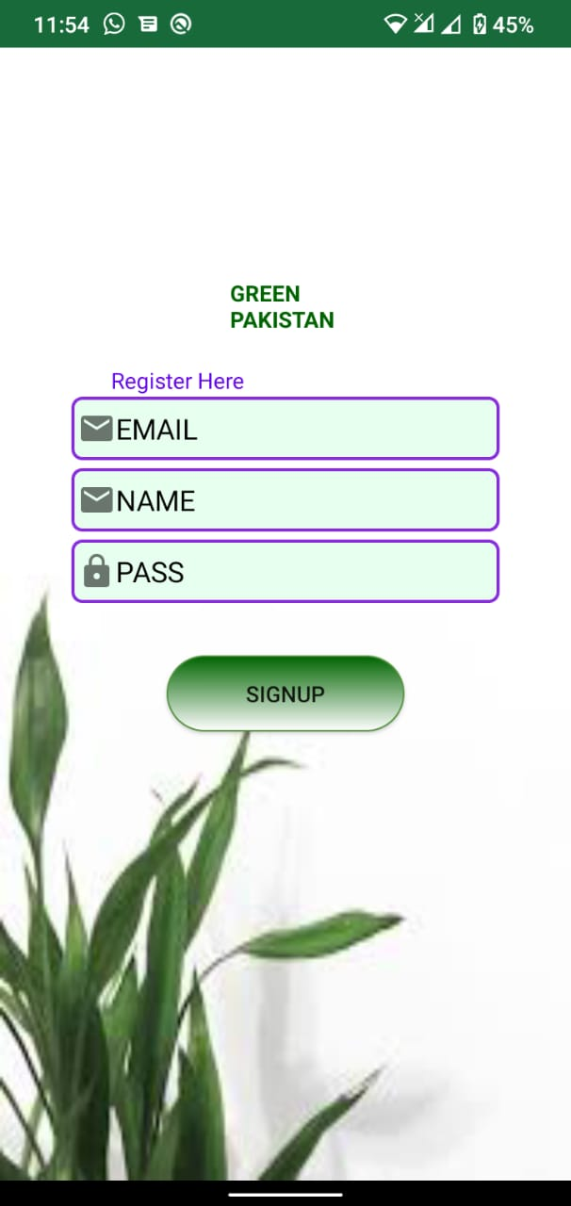

Figure 2‑2 Sign Up

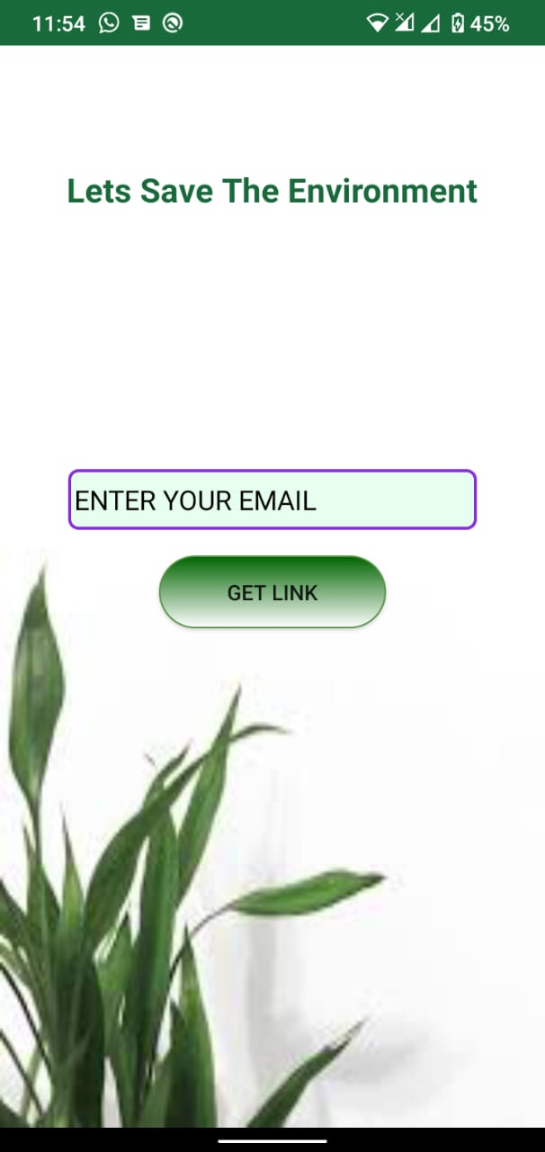

Figure 2‑3 Forget Password

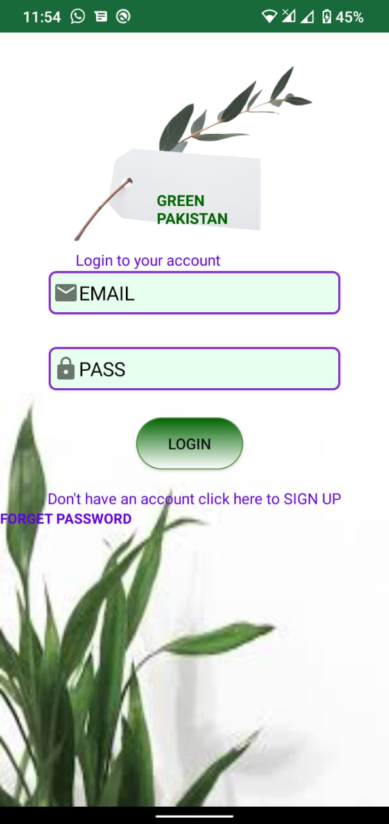

Figure 2‑4 Login

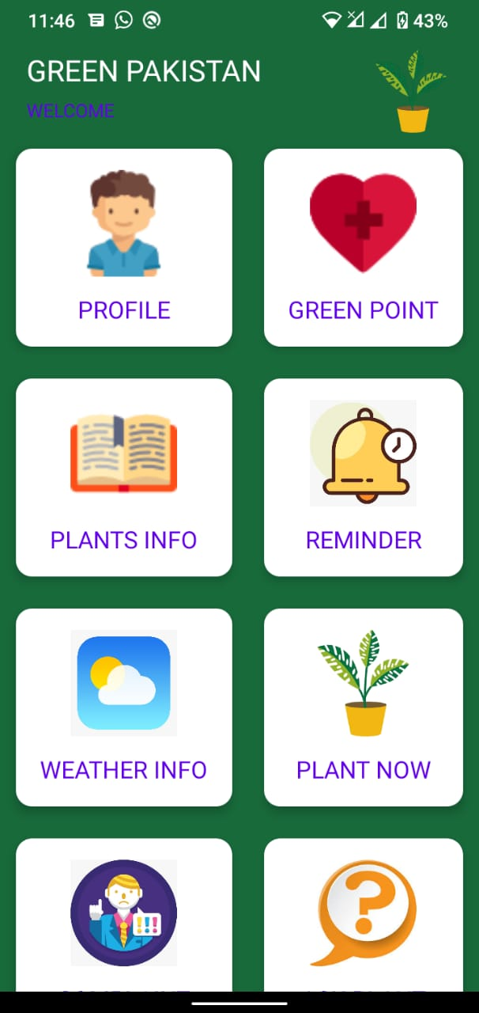

Figure 2‑5 User Dashboard

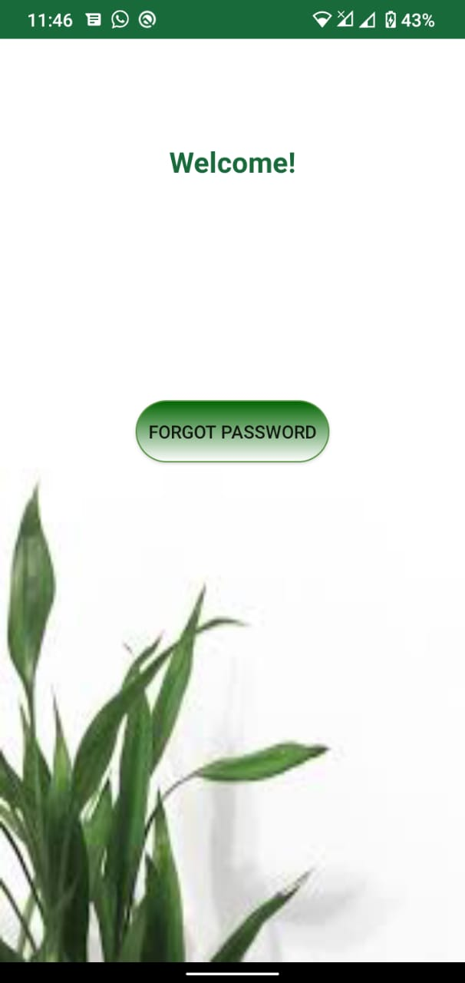

Figure 2‑6 User Profile

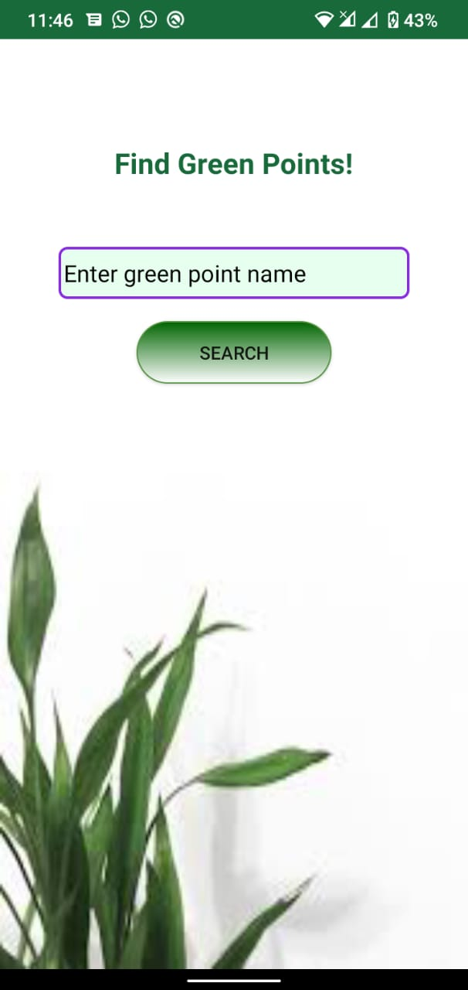

Figure 2‑7 Green Points

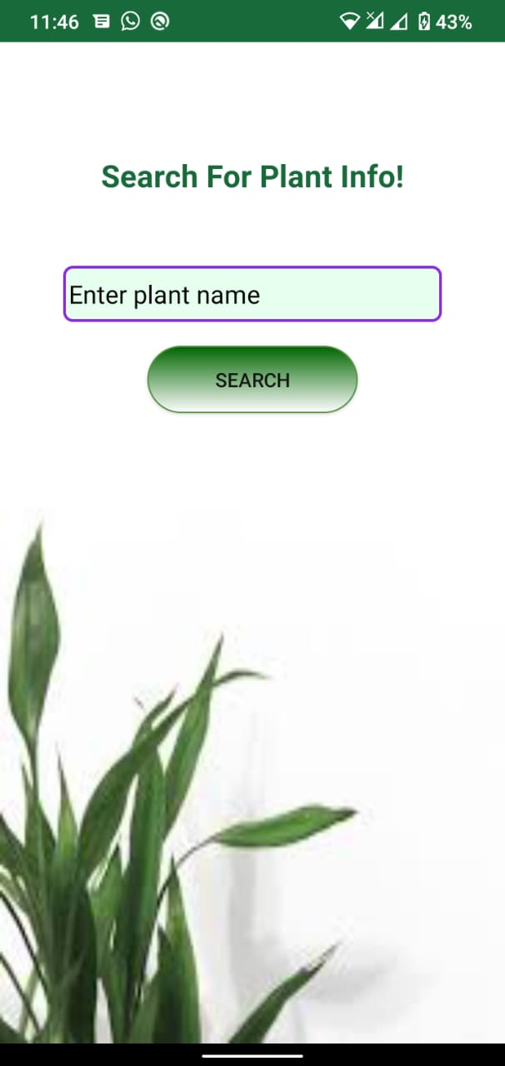

Figure 2‑8 Plant Info

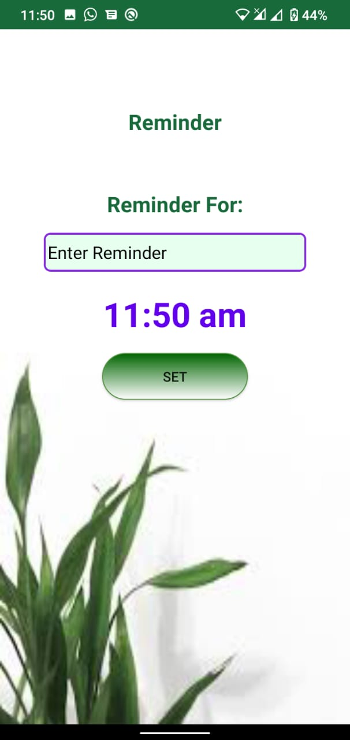

Figure 2‑9 Reminder

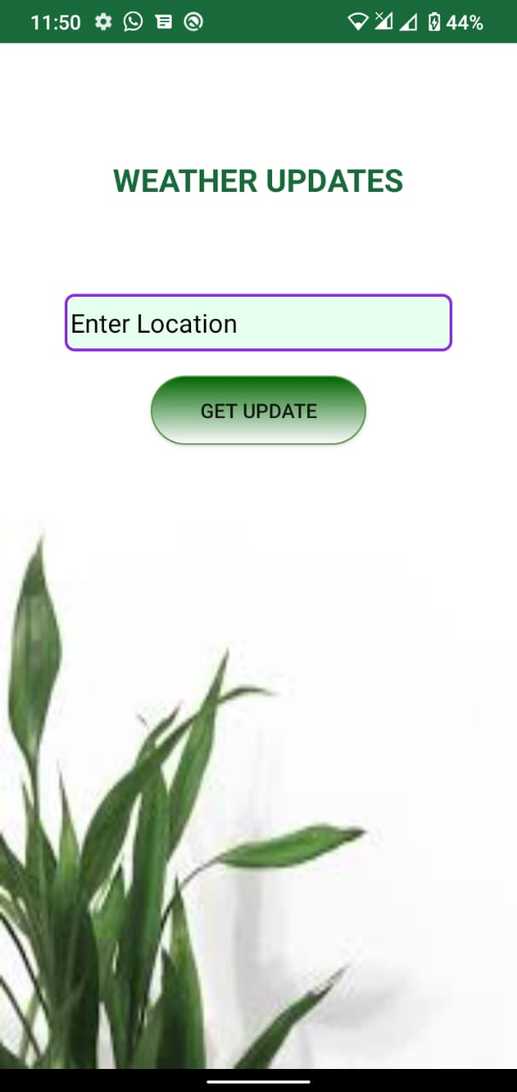

Figure 2‑10 Weather Info

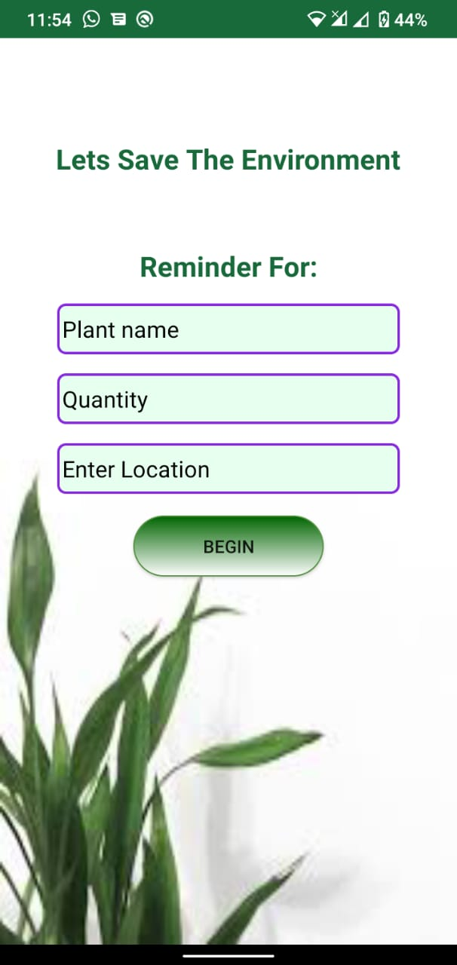

Figure 2‑11 Plant Now

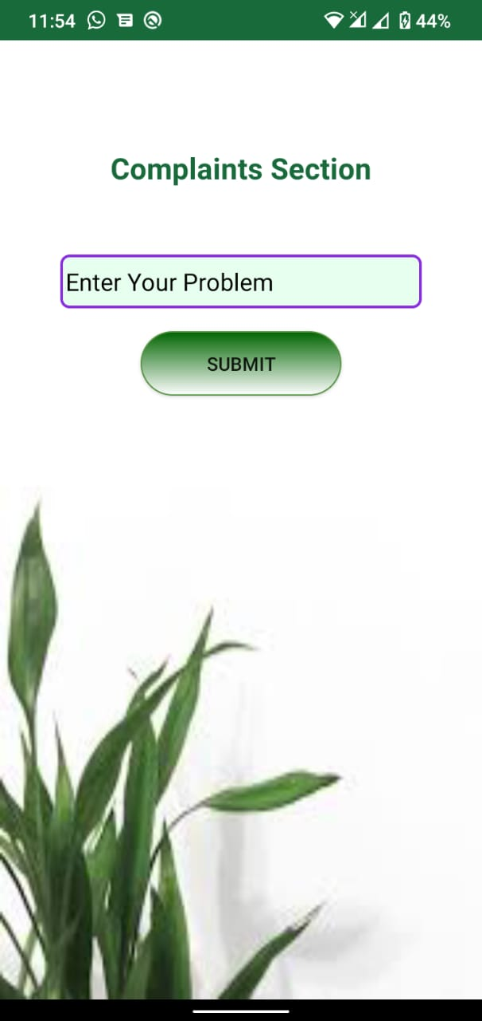

Figure 2‑12 Complaint Section



Figure 2‑13 Splash Screen

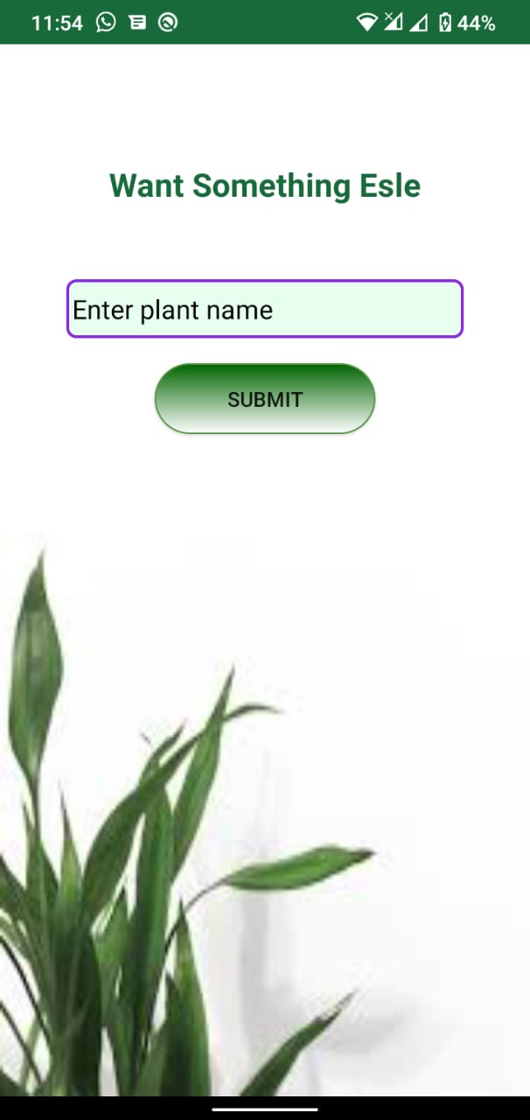

Figure 2‑14 Ask for Plant

## Analysis

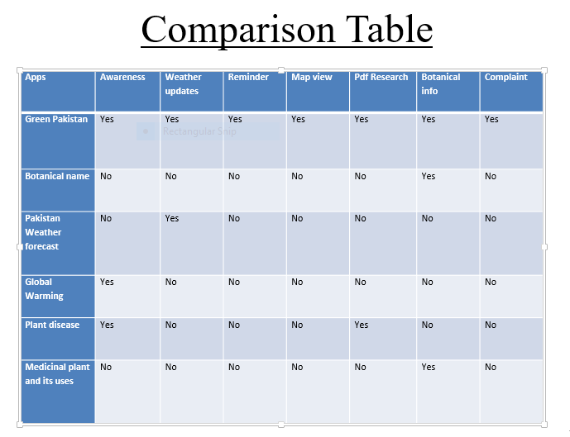

**Chapter 3**

**Requirement Specification**

# Requirement Specification

The requirements of the system are divided into functional requirements and non-functional requirements.

## Functional Requirement

### Sign Up

Volunteers can register by filling out the registration page. In the registration page, this attribute is the name, phone number, email, and password.

### Login

Users can log in with an email address and password. If the email and password are correct, the user will be eligible to log in. If the password or email is incorrect, the App will display a message "Please enter the correct email or password". There is also a "forgot password" button, in the case of forgetting the password, the user can reset the password.

### Forgot Password

When the user clicks the "Forgot Password" text box, the user skips to the next activity. The user is required to enter the correct email to send a link on their email account to reset the password. When the user clicks on the link, he/she will be asked to enter a new password.

### Change Password

When the user clicks on the "Change Password" text box, the user is required to enter the old password and to set the new password.

### View Google Maps

When volunteers click to view Google Maps, they will select the nearest green dot (5 km circle) on Google Maps. On Google Maps, we set the marker to the nearest green dot. By clicking the nearest green dot, the volunteer will jump to that green dot.

When volunteers click to view Google Maps, they will select the nearest green dot on Google Maps. On Google Maps, we set the marker to the nearest green dot. By clicking the nearest green dot, the volunteer will jump to that green dot.

### Request for Plants

Volunteers should request plants by selecting plants from the list and fill in the number and size of the plant request. A volunteer can apply for a limited number of plants, that is, 50 plants. If there are no plants, the App will display a message "Please wait a week". When the factory is available, Green Dot will send a message on its contact phone.

### View Botanical Information

Volunteer view plant information in the list view as well as plant images, plant names and common names. When the volunteer clicks on an item in the list, he/she skips to the next activity where the volunteer sees the description of the plant. In the description of this plant, plants made into herbal medicines will be mentioned.

### Set Reminder

Application should remind Volunteers to pay attention to plants. Remind you to water the plants every day.

### View Weather Updates

Volunteers will get weather updates. The weather update helps him water the plants according to the weather of the day.

### Register Complaint

The volunteer should complain to Green Point as if he had any complaints about Green Point.

### Recommendation for Plant

Recommendation for plants that which plant is good according to weather.

### Set Inspection Reminder

The green point should set a reminder every week to check the plants.

### Add Plant Record

Green point adds plant records. In the plant record, the name of the plant, the number of plants, and the appropriate area for plants that can grow perfectly are suggested

### Delete Plant Record

Green point can delete point records

### Update Plant Record

Green point can update pant record

### Admin Add Green Points

The administrator can add green points. The name of the green point, the name of the contact person, and the contact number of the contact person store their latitude and longitude in the database

### Admin Delete Green Points

Admin can delete Green Points

### Admin add Ministry

Admin create profile for ministry user

### Add Botanical Information

The administrator can add the plant information of the plant general name, plant name and plant picture in the database. Plant pictures are stored in firebase storage, the URL of the image is stored in real time, and then retrieved and loaded into the plant view list

### User can find Green Points

User can find the Green Points in the maps

### View Record

The Ministry of view the plant records stored in the database. Check the number of plants and record the number of available plants

### View and Response Complaints

The Ministry can view and respond to volunteer complaints

## Non-Functional Requirements

These are requirements that do not work by nature. These are the constraints in which the system must work.

### Security

Volunteers, administrators, green points, and departments will log in correctly to ensure system security.

### User friendly

The application should have a user-friendly interface. The system should be easy for all users. All small parts should be placed correctly. The user interface is easy to understand.

**Chapter 4**

**Project Design**

# Project Design

## Use Case Diagram

### Volunteer Use Case Diagram

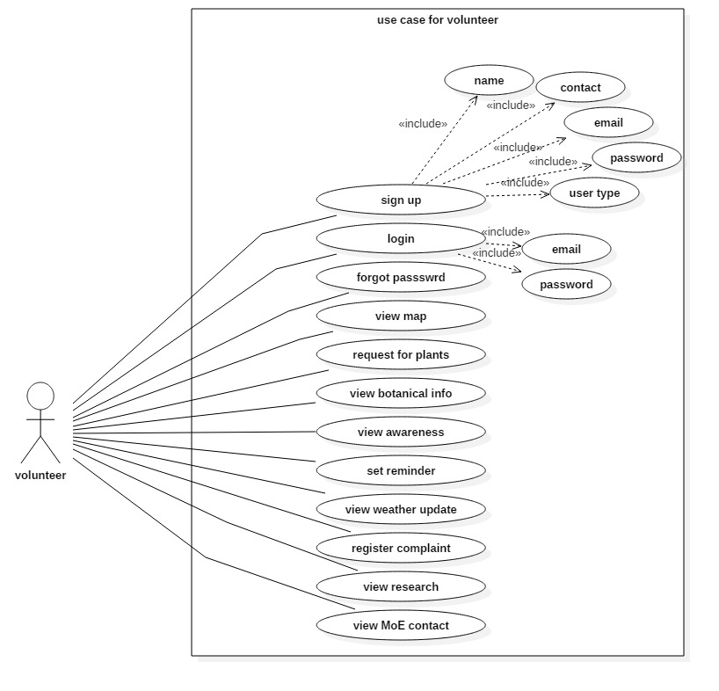

Figure 4‑1 Volunteer Use Case Diagram

#### Sign Up

You can register a volunteer by filling in the registration page. On the registration page, the volunteer (user) enters their name, contact information, email, and password. If the email address is already registered, the app will display a message indicating that you are already registered.

#### Login

You can log in to volunteers by writing your email and password. If the email and password are the same, the volunteer can log in successfully. If the email is invalid, it will display a message that does not exist.

#### Forget Password

If volunteers forget their password application, they can provide the function of forgetting the password. It requires the correct email of the registered user in the application. If the email is the correct Firebase, please send the link on its email. By clicking the link, volunteers can reset their password and enter a new password. If the email is incorrect, only one wrong email is displayed.

#### View Maps

On the map, volunteers look at the nearest green Point as a marker. By clicking on the marker, volunteers can jump to plant request activities and plant requests. When volunteers request to view the map, the application will obtain the longitude and latitude from the database and display them on the map.

#### Request Plants

Volunteers request plant by entering the plant name and quantity. If the plant is not available, it will display a message and wait for a weak current. When the plant is available, Green Point will send a message on its contact phone.

#### View Botanical Information

Volunteer view plant information in the list view as well as plant images, plant names and common names. When the volunteer clicks on an item in the list, he/she skips to the next activity where the volunteer sees the description of the plant. In the description of this plant, plants made into herbal medicines will be mentioned.

#### View Awareness

Volunteers will realize the importance of plants. What kind of problems will society face due to the reduction of plants?

#### Set Reminder

Volunteers can set reminders for watering every day

#### View Weather Update

Volunteers will get weather updates. The weather update helps him water the plants according to the weather of the day.

#### Register Complaint

If they have questions about Green Point, the volunteers will register their complaint in the Service Department. For volunteers who register a complaint, select the green dot, then click the green Point in the list item, then submit to the complaint registration form, and then submit the complaint here. The volunteer only fills in the complaint description, the system will always get their name and contact Way, green Point name, contact information. Numbers and IDs in the database.

#### View Research

Volunteers conduct research on plants. The research is displayed in a list view. Retrieved from the database

#### View Contact

Volunteers check contact numbers and department emails.

### Admin Use Case Diagram

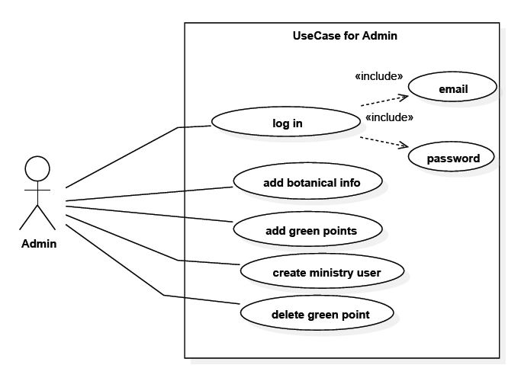

Figure 4‑2 Admin Use Case Diagram

#### Login

You can log in to the administrator by writing email and password. If the name and password are the same, the volunteer can log in successfully. If the email is invalid, it will display a message that does not exist

#### Add Botanical Info

The administrator adds plant information to the database. Add the common name and description of the image plant name.

#### Add Green Point

The administrator adds a green Point. Obtain the longitude and latitude and store the name of the focus person with the name of the green point and the telephone number of the green point.

#### Create ministry User

The administrator assigns a unique email and password, which are stored in Firebase. You can use this email address to register for ministry

#### Delete Green Point

The administrator can delete the green point by clicking the delete button on the list item.

### Use Case for Green Point

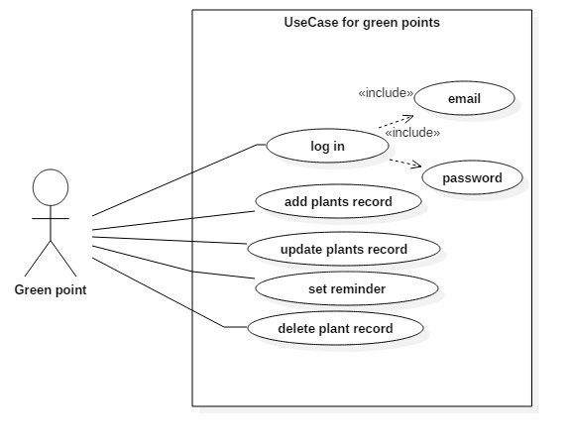

Figure 4‑3 Use Case for Green Point

#### Login

You can log in to Green point by writing email and password. If the name and password are the same, the volunteer can log in successfully. If the email is invalid, it will display a message that does not exist.

#### Add Plant record

Green Point added plants are recorded in the database. Add the plant name, number of plants and suggested area to the record.

#### Update Plant record

The administrator can update the plant by clicking the delete button on the list item.

#### Delete Plant record

The administrator can delete the plant by clicking the delete button on the list item.

#### Set Reminder

The green point sets inspection reminders for factory inspections.

### Use Case for Ministry

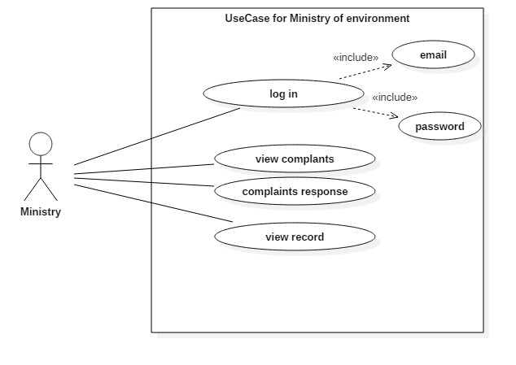

Figure 4‑4 Use Case for Ministry

#### Login

You can log in to Green point by writing email and password. If the name and password are the same, the volunteer can log in successfully. If the email is invalid, then it will display a message does not exist.

#### View Complaints

Ministry can see complaints

#### View Record

Department can view the records of the factory. It retrieves data from the plant database and checks plant records.

## Activity Diagram

### Admin Activity Diagram

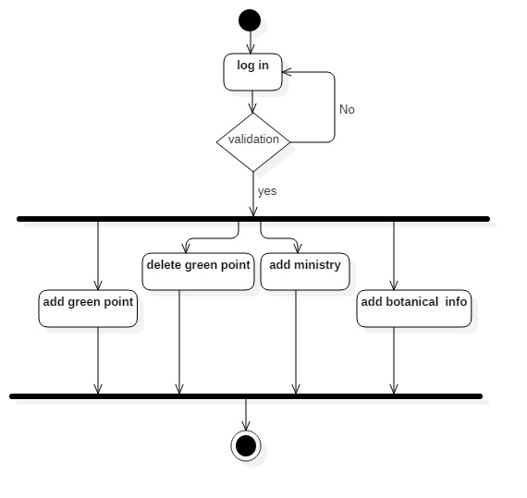

Figure 4‑5 Admin Activity Diagram

The figure above shows the admin activity. The login screen appears first. If the admin types the email and password correctly, he/she successfully logs in and he/she can see the functions of the application. After logging in, there are multiple functions/modules on the admin dashboard. Add green points, delete green points, create ministry users, and add plant information.

### Green Points Activity Diagram

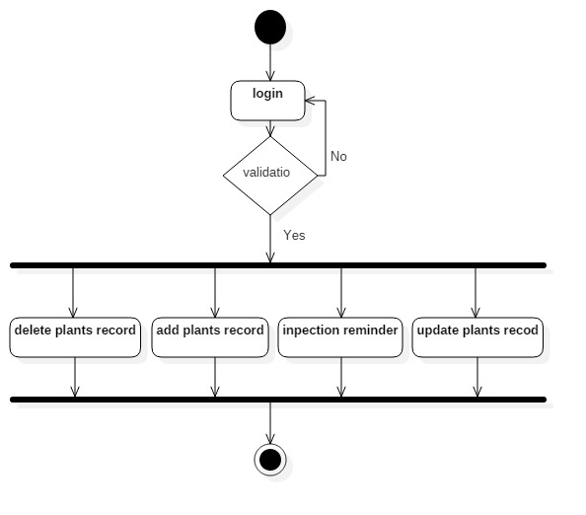

Figure 4‑6 Green Point Activity Diagram

The image above shows the activity of the green points. The login screen appears first. If the green dot contact person enters the email and password correctly, he/she successfully logs in and he/she can use the functions of the application.

After logging in, there are multiple functional components/modules on the green dot dashboard. Add plant records, plant factory records, update plant records, set reminders.

### Activity Diagram of Ministry

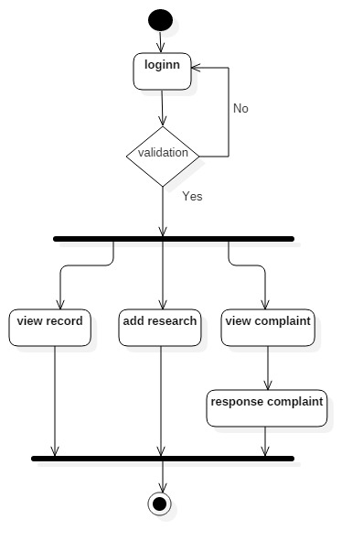

Figure 4‑7 Activity Diagram of Ministry

The figure above shows the department's activities. The login screen appears first. If the department user correctly enters the email and password, he/she successfully logs in and he/she can add functions to the application. After logging in, there are multiple functions/modules on the dashboard. View complaints, add research, view records.

### Activity Diagram of User

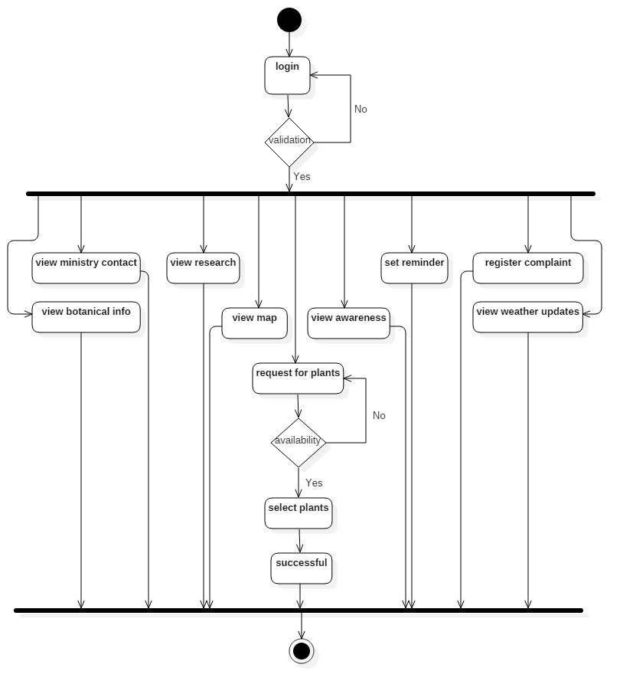

Figure 4‑8 Activity Diagram of User

The picture above shows the activities of volunteers. The login form appears first. After the volunteers correctly enter the email and password, they can successfully log in and use the functions of the application. After logging in, there are multiple functions/modules on the volunteer's dashboard. Volunteers can view plant information, view awareness, view research, view weather updates, register for complaints, set reminders, view maps, and request plants when there are plants.

### Activity Diagram of User Sign Up

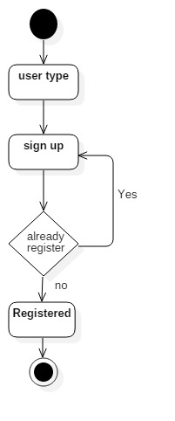

Figure 4‑9 Activity Diagram of User Sign Up

The above figure shows the registration activity fills out the registration page and successfully registered. If it is already registered, a message is displayed.

### Sequence Diagram

#### Sign Up Sequence Diagram

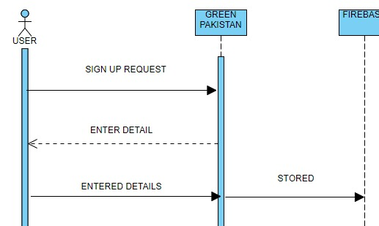

Figure 4‑10 Sign Up Sequence Diagram

#### Login Sequence Diagram

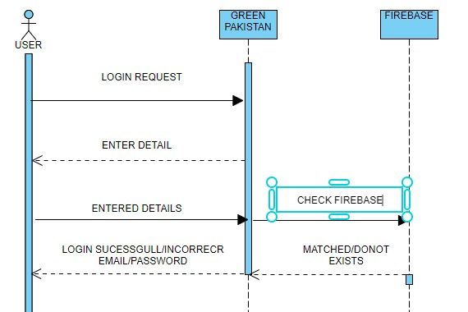

Figure 4‑11 Login Sequence Diagram

#### View Map Sequence Diagram

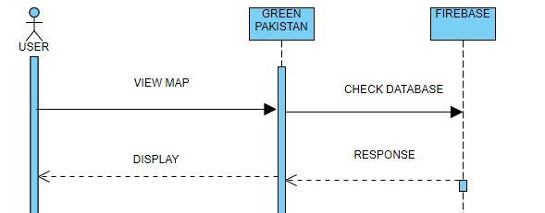

Figure 4‑12 View Map Sequence Diagram

#### Plant Request Sequence Diagram

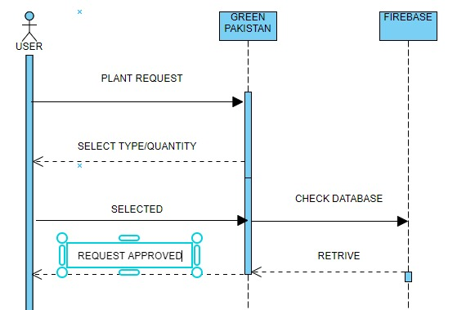

Figure 4‑13 Plant Request Sequence Diagram

#### View Botanical Sequence Diagram

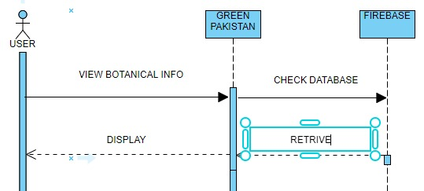

Figure 4‑14 View Botanical Sequence Diagram

#### Set Reminder Sequence Diagram

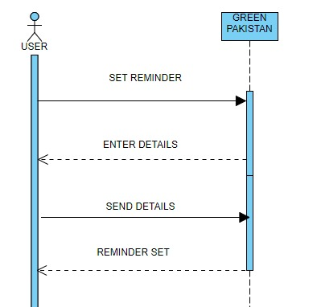

Figure 4‑15 Set Reminder Sequence Diagram

#### Add Botanical Information Sequence Diagram

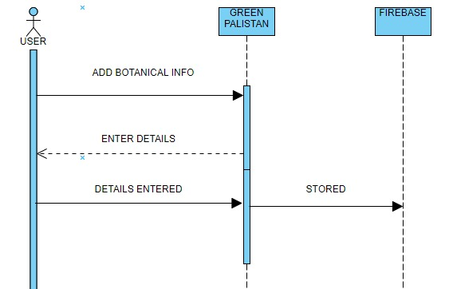

Figure 4‑16 Add Botanical Information Sequence Diagram

#### View Weather Sequence Diagram

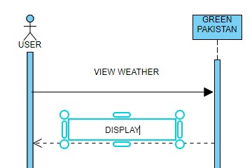

Figure 4‑17 View Weather Sequence Diagram

#### Add Request Sequence Diagram

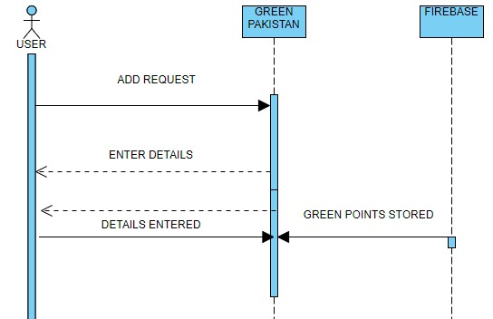

Figure 4‑18 Add Request Sequence Diagram

#### Delete Request Sequence Diagram

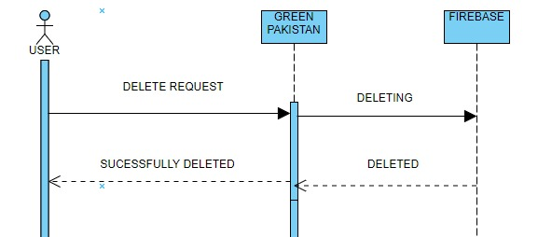

Figure 4‑19 Delete Request Sequence Diagram

#### Register Complain Sequence Diagram

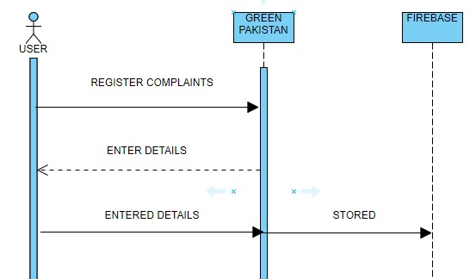

Figure 4‑20 Register Complain Sequence Diagram

#### View Complaint Request Sequence Diagram

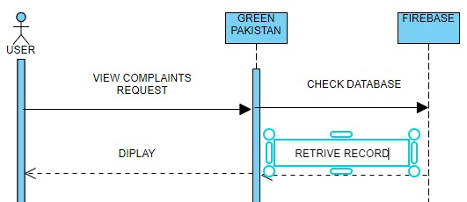

Figure 4‑21 View Complaint Request Sequence Diagram

#### Request for Plant Update Sequence Diagram

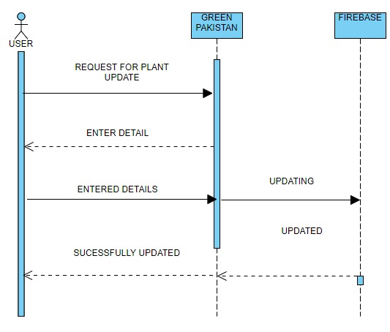

Figure 4‑22 Request for Plant Update Sequence Diagram

#### View Research

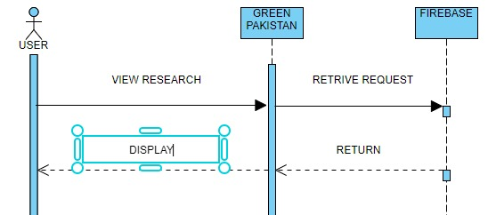

Figure 4‑23 View Research Sequence Diagram

#### Set Inspector Sequence Diagram

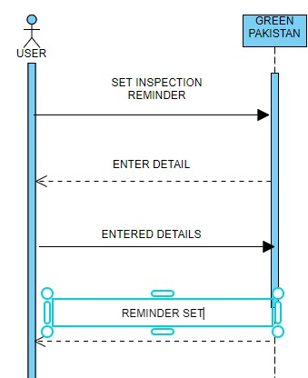

Figure 4‑24 Set Inspector Sequence Diagram

#### View Contact Detail of Ministry

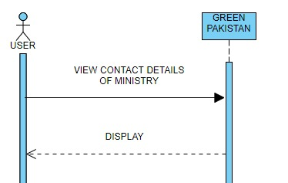

Figure 4‑25 View Contact Detail of Ministry Sequence Diagram

### Data Flow Diagram

#### Data Flow Diagram (Level-0)

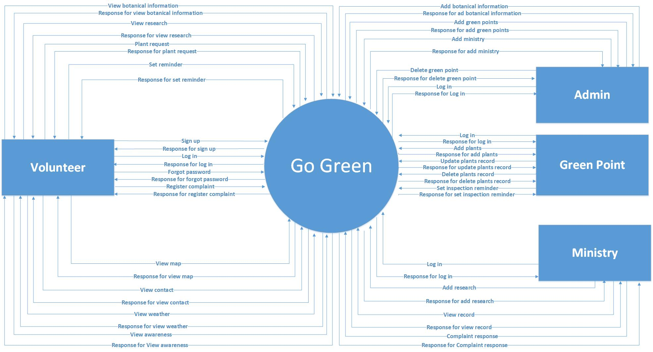

Figure 4‑26 Data Flow Diagram (Level-0)

The figure above shows that the DFD level is zero. In level zero, the entire system is considered a process. There are three external entities: volunteers, managing Green Dot and the service department. Every entity interacts with the system. The system responds to entity input.

**USER**

* When volunteers apply for the registration system, please add the Firebase database, and display a message of successful registration.
* When volunteers request to log in to the system, please check their email and password in the Firebase system database and allow the user to log in successfully.
* When the volunteer asks for the forgotten password system, an email is used as input and sent to Firebase for authentication.
* When volunteers request to view the map system, retrieve the longitude and latitude from the database and display the markers on the map.
* Show it when volunteers request the view-aware system.
* When the volunteer's factory request system retrieves the green dot list, and the volunteer selects one of them according to their wishes and fills in the factory request form stored in the database.
* When a volunteer asks to view the plant information system to retrieve a list of plant name images and plant descriptions from the database and display them in the list
* When volunteers ask to view the weather update system, get data from the weather API, and display it on the screen
* When volunteers request to register in the complaint system, a complaint form will be displayed to voluntarily fill out the complaint form, and then the system will store the complaint information in the database.
* When a volunteer asks to set up a reminder system, please get the reminder information from the volunteer and open the service
* When a volunteer requests to view the research system, the research list is retrieved from the database and displayed in the list.

**ADMIN**

* When the administrator asks to log in to the system, please check its email and password in the Firebase database and allow the user to log in successfully.
* When the administrator asks to add a green dot, the system will obtain the longitude and latitude, the name of the green dot, the name of the contact person, the phone number, email and password, and store them in the database.
* When the administrator requests to add a plant information system, please obtain the image plant name and description and store it in the database.
* When the administrator asks to add a ministries system, please use email and password and store in Firebase authentication.
* The administrator asks the system to delete the green dot to delete the green from the database from the requested ID

**GREEN POINT**

* When Green Dot asks to log in to the system, please check its email and password in the Firebase system database and allow the user to log in successfully.
* When Green Dot asks the system to add plants to obtain plant records and store them in the database
* When the green dot of the check reminder system is set to obtain reminder information from volunteers, please turn on the service.
* When Green Dot requests to delete the factory system, delete the factory from the database of the request ID
* When Green Dot requests to update the factory system, it will update the factory records in the database according to the requested ID

**MINISTRY**

* When the department asks to log in to the system, please check its email and password in the Firebase system database and allow the user to log in successfully.
* When the Ministry requests to view the complaint system, all complaints are retrieved from the database and displayed in the list.
* When the department requests to add a research system, the research files are used as input and stored in the database.
* When the Ministry requests to view the records system, retrieve a list of all plant records from the database

#### Data Flow Diagram (Level-1)

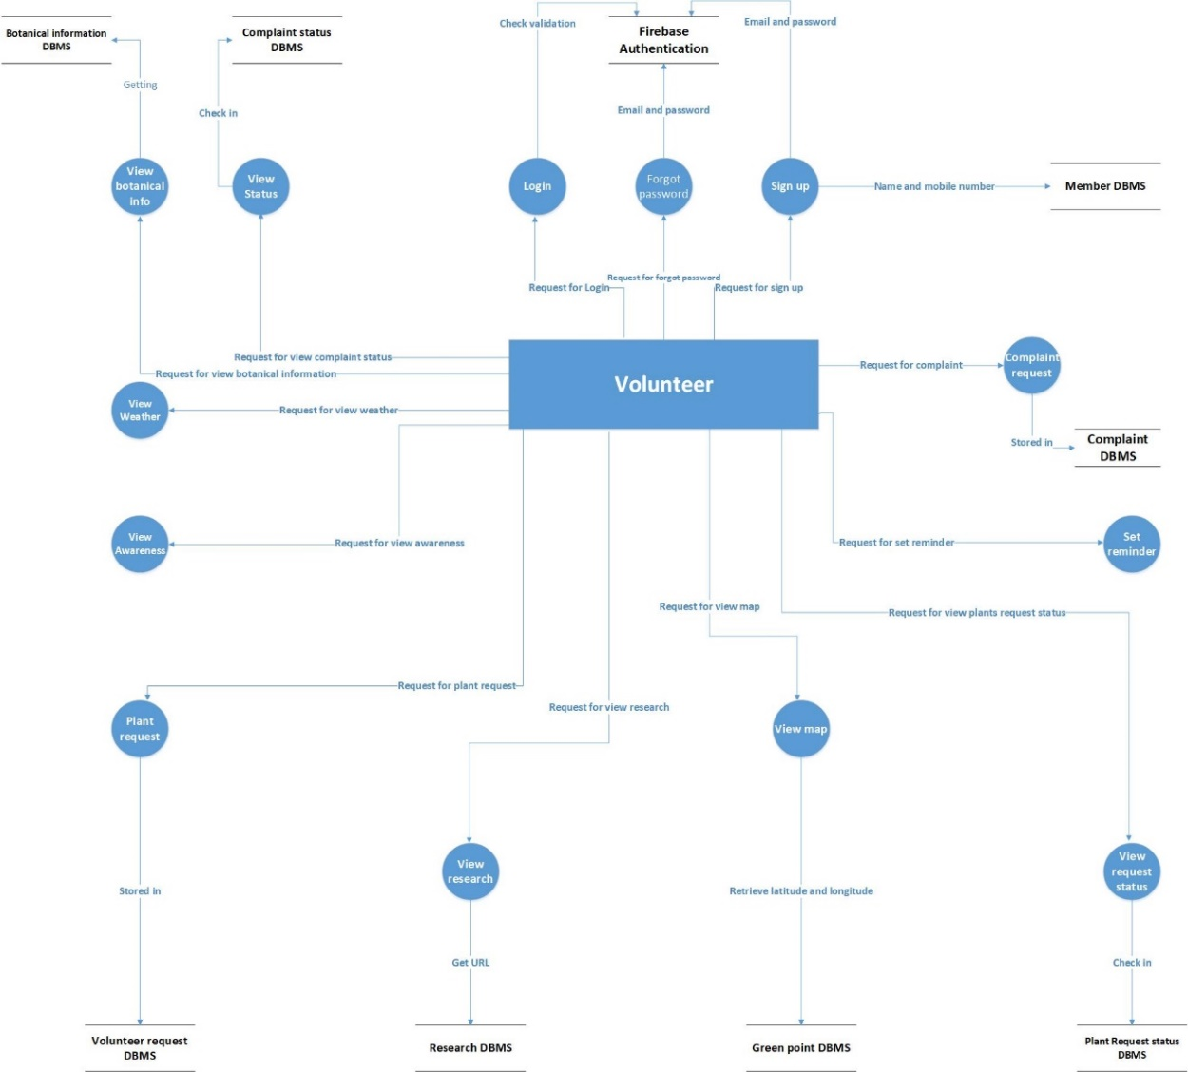

Figure 4‑27 Data Flow Diagram (Level-1)

**USER**

* When a volunteer requests registration, this request is handled by a process. This process stores the data in Firebase.
* When a volunteer requests to log in, this input is processed by login. The login process matches the email and password in firebase.
* When a volunteer requests a forgotten password, this input is handled by a process, and this process sends an email to Firebase for authentication
* When a volunteer requests to add a view map to the process. The view map process will get the longitude and latitude from the green dot database and display the map.
* When the volunteer's request to the factory is handled by the factory's process request. This process retrieves the green dot record from the database in JSON format, converts it into a list of volunteer requests to the green dot, and stores the request data in the factory. database.
* When a volunteer requests perception, the view perception process will send display perception.
* When a volunteer requests a View Research, the request will be sent to the View Research process. This process retrieves the research from the database and displays it in the list.
* When a volunteer requests a reminder, it will be handled by the reminder setting process. This process will open the reminder service.
* When volunteers request to register a complaint. This input is handled by the process registration complaint. It will accept the complaint description and store it in the database.
* When volunteers request weather updates. The request will be sent to the "Check Weather Update" process. The weather check process shows the weather update.

**DFD LEVEL 1 FOR ADMIN**

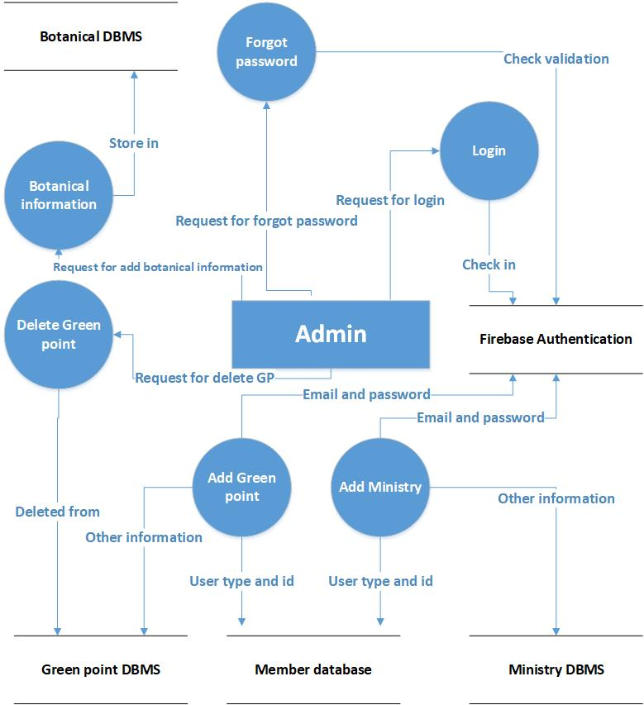

Figure 4‑28 DFD for Admin (Level 1)

**ADMIN**

* When the administrator asks to add a green dot. The request is sent to the "add green dot" process. The process inputs data and stores it in the database.
* When the administrator asks to log in, this input is processed by login. The login process matches the email and password in firebase.
* When the administrator requests the creation of a user profile. This will be sent to the process adding department, which will add email and password and other data in the real-time database to the firebase authentication.
* When the administrator requests to add plant information. The request is handled by a process. Adding plant information This process takes the plant name, common name, description, and image of the plant and stores it in the database.
* When the administrator requests to delete the green dot, this input is processed by the process of deleting the green dot. It will delete the green dot on that ID.

**DFD LEVEL1 FOR MINISTRY**

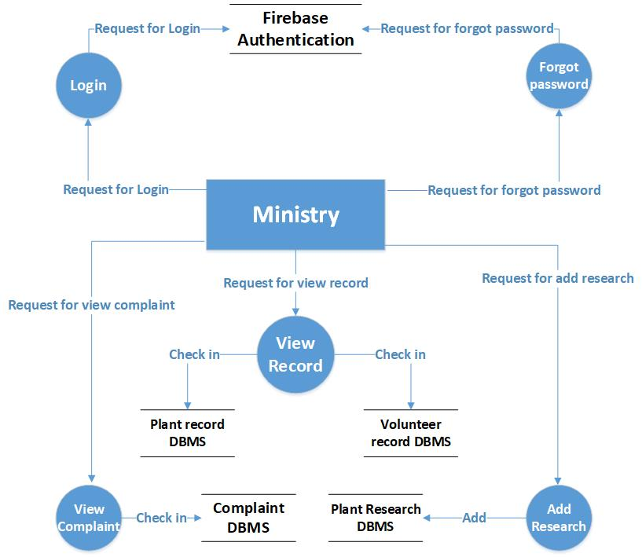

Figure 4‑28 DFD for Ministry (Level-1)

**MINISTRY**

* When the department requests login, this input is handled by the login. The login process matches the email and password in firebase.
* When the ministry requires additional research, this input is processed by the process addition research. The process gets data and stores it in the database.
* When the department requests to view factory records, the request is handled by the process "View Records". This process retrieves records in JSON format and converts them and displays them in a list.
* When the Ministry of Labour requests a complaint response. This input is handled by the process Complaint response. This process retrieves the complaint list from the database in JSON format, converts it and displays it in the list.

**DFD LEVEL 1 FOR GREEN POINT**

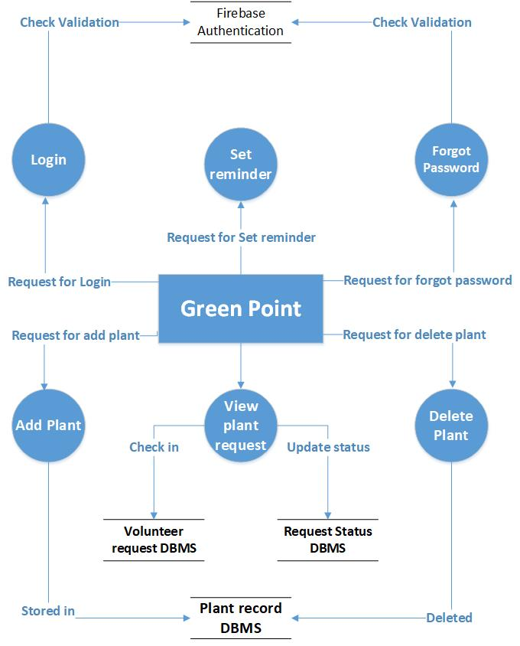

Figure 4‑29 DFD for Green Point (Level-1)

**GREEN POINT**

* When a green login request is made, this input is processed by login. The login process matches the email and password in firebase.
* When Green Dot requests to add a factory record, this input is processed by the process adding factory. It obtains plant data and stores it in a database.
* When Green Dot requests to set a reminder, it is handled by the set reminder process, which opens the reminder service every week.
* When green delete factory request, this input is processed by delete green dot. It deletes the factory on that ID from the database.
* When Green requests to update the factory, this input is processed by the update factory process. It updates the factory on that ID from the database.

